Ardingly Court Surgery
Confidential Health Questionnaire for New Patients

Please complete your form and hand in to Reception
If you are unsure of anything, please ask a member of staff at Reception for assistance.

Name:

Marital Status: Single Married Cohabiting Separated Divorced Widowed

Family Medical History
Please specify if any of your close relatives have suffered from any significant medical problems (who and diagnosis):

Blood Pressure
Systolic Reading: Diastolic Reading: Pulse:

If you do not have a blood pressure machine at home, please use the one in Reception to complete this section.

Text Message Consent
We offer a text messaging service, allowing you to receive reminders of your appointment time and other important communications from the Practice.

Do you consent to receiving messages from us via text? Yes No

Online Access
By providing us with your email address we can set up an account which you can use to book appointments and order your medication quickly online.
Yes I would like online access No I do not want online access

Email Address:

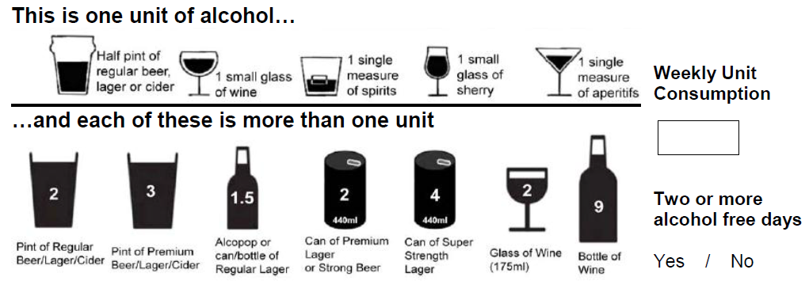

The following questions are validated as screening tools for alcohol use
AUDIT - C:  First 3 Questions |  | Scoring system |  |  |  |  | Your score
 |  | 0 | 1 | 2 | 3 | 4 | Your score
1 | How often do you have a drink containing alcohol? | Never | Monthly  or less | 2-4 times per month | 2-3 times per week | 4+ times per week
2 | How many units of alcohol do you drink on a typical day when you are drinking? | 1 -2 | 3-4 | 5-6 | 7-9 | 10+
3 | How often have you had 6 or more units if female, or 8 or more if male, on a single occasion in the last year? | Never | Less than monthly | Monthly | Weekly | Daily or almost daily
Total score for questions 1-3 =
Full AUDIT:  Remaining 7 Questions |  | Scoring system |  |  |  |  | Your score
 |  | 0 | 1 | 2 | 3 | 4 | Your score
4 | How often during the last year have you found that you were not able to stop drinking once you had started? | Never | Less than monthly | Monthly | Weekly | Daily or almost daily
5 | How often during the last year have you failed to do what was normally expected from you because of your drinking? | Never | Less than monthly | Monthly | Weekly | Daily or almost daily
6 | How often during the last year have you needed an alcoholic drink in the morning to get yourself going after a heavy drinking session? | Never | Less than monthly | Monthly | Weekly | Daily or almost daily
7 | How often during the last year have you had a feeling of guilt or remorse after drinking? | Never | Less than monthly | Monthly | Weekly | Daily or almost daily
8 | How often during the last year have you been unable to remember what happened the night before because you had been drinking? | Never | Less than monthly | Monthly | Weekly | Daily or almost daily
9 | Have you or somebody else been injured as a result of your drinking? | No |  | Yes, but not in the last year |  | Yes, during the last year
10 | Has a relative or friend, doctor or other health worker been concerned about your drinking or suggested that you cut down? | No |  | Yes, but not in the last year |  | Yes, during the last year
Total score for questions 7-10 =
TOTAL score for ALL questions =

Important Note:

If you are unsure of anything, please speak with a receptionist.
If the forms are incomplete or you forget to bring ID, your registration will be delayed.
Registrations can take between 7 and 10 days to be processed.

You must therefore obtain at least 2 weeks medication from your previous surgery before submitting your application to join Ardingly Court Surgery. Failure to do this may leave you without medication due to the time aspect of the registration process, please also inform reception if you receive your medication in a blister pack.

Please sign below and hand back to reception

Signature………………………………………………………….……. Date………………………………………………………

Office use only

Photographic ID  Driver’s Licence or Passport | Proof of Residence  Utility Bill, Bank Statement, Council Letter,  Tenancy or Mortgage Agreement

Checked by: Date:

